**Roller Coaster**

1. Introduction
   1. Understanding the dataset
   2. What we solved
2. Research and visualization
   1. Top 5 roller coasters
   2. Heigh Of Roller Coasters
   3. Roller Coaster Status
   4. Roller Coaster Features
   5. Top 10 parks by coaster’s feature
   6. Feature VS Seating type
   7. Speed VS Height
   8. Inversions of Six Flags Roller Coasters
3. Conclusions

## **Introduction**

Ever dreamt of defying gravity and unleashing your inner thrill-seeker? Roller coasters, those steel and wooden giants of amusement parks, offer a heart-pounding escape from reality. But today, we're flipping the script! Prepare to dive into the data, analyzing rankings and statistics to uncover the secrets behind these adrenaline-pumping machines. From crowning champions to exploring trends, we'll explore the captivating world of roller coasters.

I've already built some handy functions to help you:

* Compare rollercoaster rankings over time.
* Discover the top-rated coasters in the world.
* Find any information you crave about your favorite coasters.
* Check out all the rides in a specific park.
* Uncover which parks have the most mind-bending inversions.

### **1.1 Understanding the dataset**

Roller coasters are often split into two main categories based on their construction material: wood or steel. Rankings for the best wood and steel roller coasters from the 2013 to 2018 Golden Ticket Awards and  [Captain Coaster](https://captaincoaster.com/en/) are provided in:

Datasets:

* **steel**: Golden_Ticket_Award_Winners_Steel.csv
* **wood:** Golden_Ticket_Award_Winners_Wood.csv
* **roller_coasters:** roller_coasters.csv

Columns:

* **Name:** Name of the roller coasters
* **Park:** Location of roller coasters
* **Supplier**: The company who build roller coasters
* **Location**: Location of roller coasters
* **Points:** Visitors points for roller coasters
* **material_type**: Wood or steel construction
* **seating_type**: How riders are secured
* **speed**: speed in miles per hour
* **height**: Maximum drop
* **length**: How much track to conquer
* **num_inversions**: Upside-down loops
* **manufacturer**: The company behind the coasters
* **status**: Is coaster operating or closed

### **1.2 What we solved**

Unleash the mysteries of the coaster universe! This analysis provides answers and insights to satisfy your roller coaster curiosity.

1. Which rides consistently rank among the world's most thrilling roller coasters?
2. What is the typical height range for roller coasters, and are there outliers that challenge expectations?
3. What percentage of roller coasters are currently operational?
4. Which parks stand out for exhibiting the highest combination of speed, length, and inversions?
5. How do different seating types influence the experience of riding roller coasters?
6. To what extent does the height of a roller coaster correlate with its maximum speed?

## **Analysis**

### **Top 5 roller coasters**

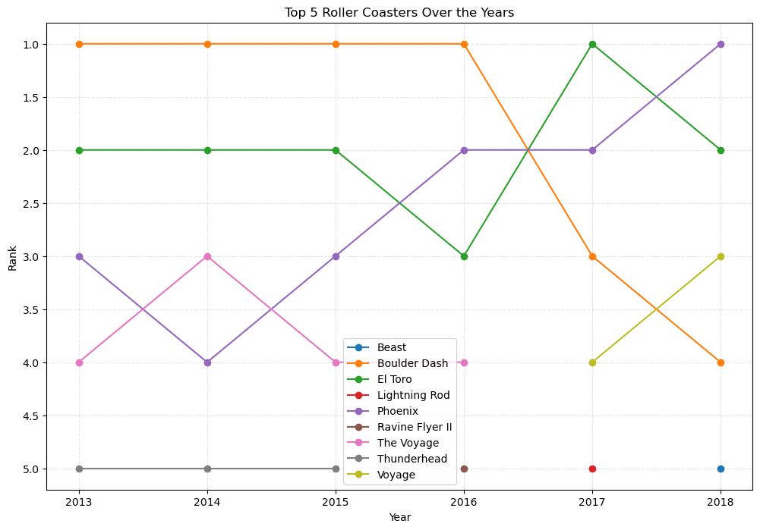

From 2013 to 2018, Boulder Dash dominated the top spot, reigning as the ultimate thrill machine. However, 2016 marked a shift in the rankings, with the rising star, El Toro, knocking Boulder Dash down to second place. Phoenix joined the top contenders in 2016, claiming second place before El Toro recaptured the crown in 2017. Throughout these years, Voyage carved its own path, consistently securing a top 4 spot. Finally, 2018 saw Phoenix reclaiming the gold, followed by El Toro, Voyage, and Boulder Dash.

### **Heigh Of Roller Coasters**

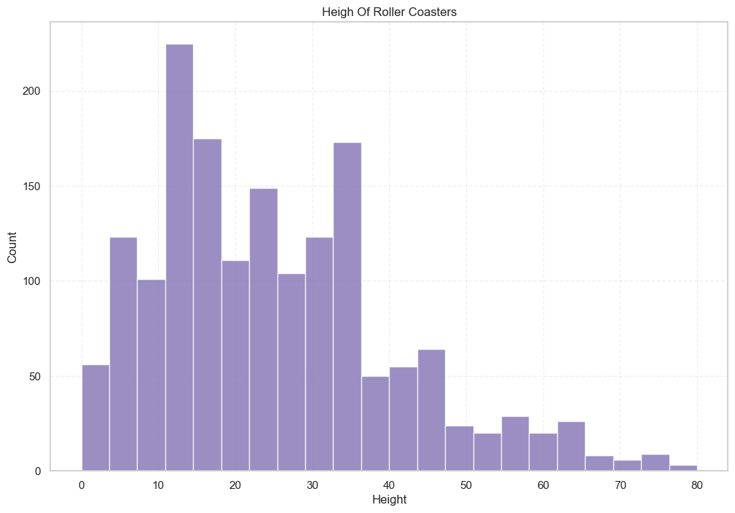

Most roller coasters stand between 5 and 37 meters tall, although a few reach soaring heights of up to 80 meters. Despite this, only a select group of about 30 coasters rise above 50 meters.

### **Roller Coaster Status**

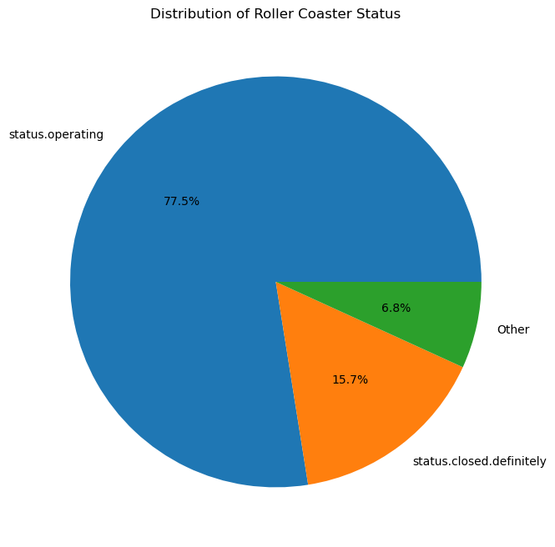

The datasets show that an impressive 77.5% of coasters are currently operating, with 15.7% on the way soon. Other statuses like construction and announcement make up less than 7%.

### **Roller Coaster Features**

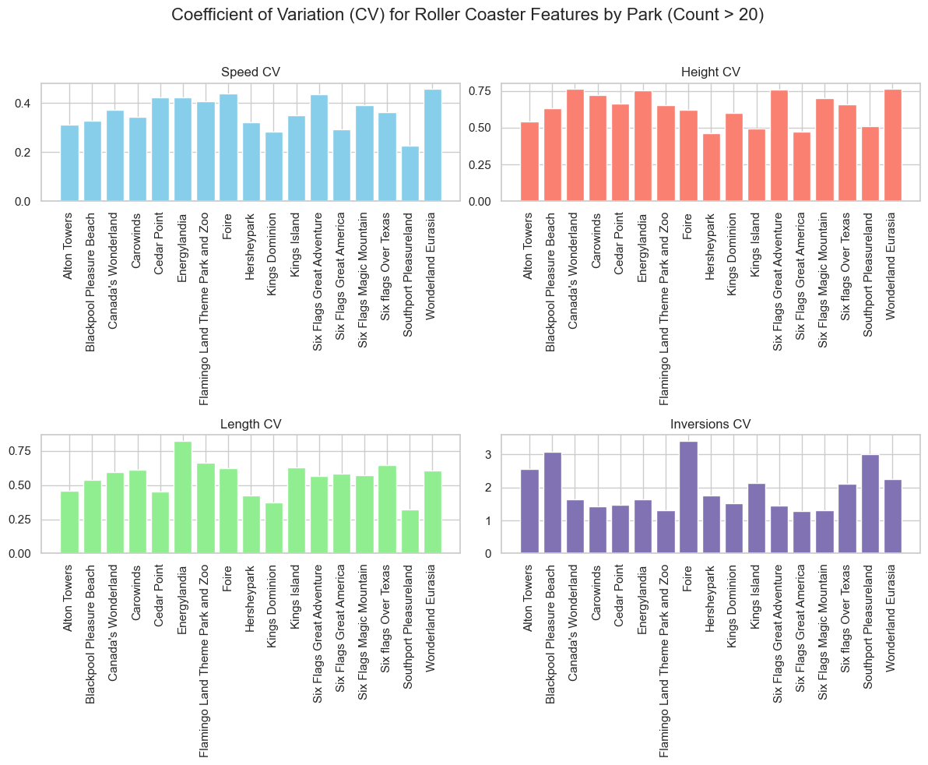

Coefficients of Variation (CV) indicates greater variability or spread in the data. This means there's a wider range of values for that feature among roller coasters in the parks. For example, a high CV for height might suggest some parks have extremely tall coasters while others have much shorter ones.

### **Top 10 parks by coaster features**

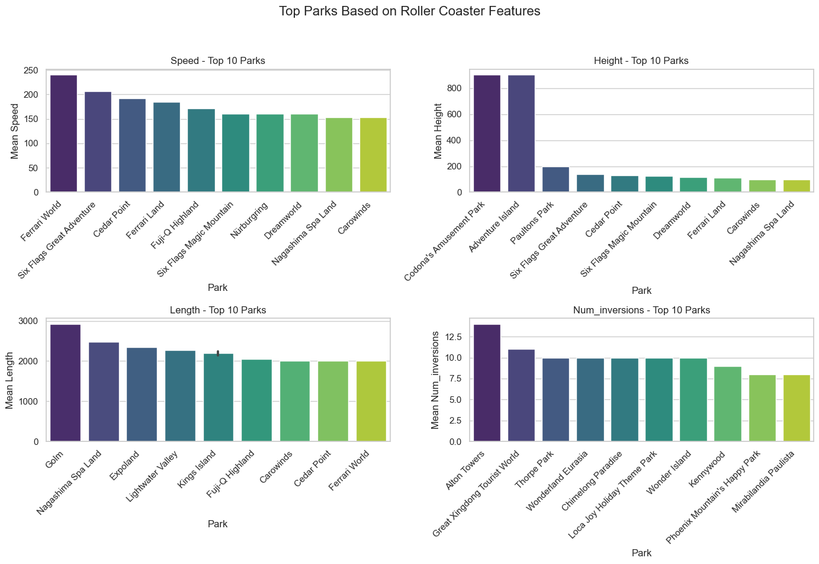

**1. Choosing Your Thrill Destination:**

Dive into the top 10 features of coasters across different parks and plot your next adrenaline-pumping adventure! Whether you crave heart-stopping speeds, gravity-defying inversions, or epic journeys on the longest tracks, there's a perfect coaster out there waiting for you.

**2. Speed Demons Rejoice:**

Calling all speed junkies! Buckle up for the breakneck thrills of Ferrari World's top speed coaster, reaching a mind-blowing 270 km/h - buckle up, you'll need it!

**3. Conquer the Distance:**

Endurance enthusiasts, prepare for a marathon ride! Golem Park boasts the longest coaster in the land, stretching for an epic 3,000 meters. Get ready to lose yourself in the thrill of the endless track.

**4. Masters of Loops and Twists:**

If flips and inversions are your jam, Alton Towers awaits! Hold on tight as you navigate a dizzying 13 inversions on their premier coaster. Prepare to lose track of up and down!

**5. Soaring Heights at Every Turn:**

Craving panoramic views and gut-wrenching drops? Both Codona's Amusement Park and Adventure Island have towering giants reaching almost 800 meters. These sky-high coasters offer breathtaking moments suspended above the world.

### **Feature vs Seating Type**

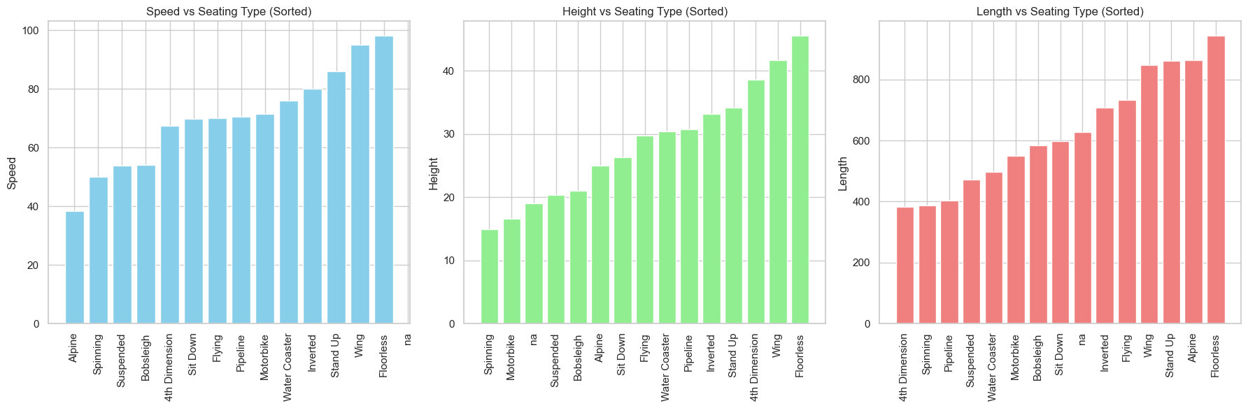

Seat types play a crucial role in the roller coaster experience, influencing everything from speed and thrills to comfort and unique perspectives. To unlock the secrets of this connection, I compared each seat type with various coaster features.

While sit-down seats dominate the coaster landscape (2217 strong!), some niche kings reign supreme in specific realms.

Floorless seats, as expected, claim the throne for overall experience, offering unrivaled immersion and breathtaking drops. But when it comes to specific thrills, the battle for dominance heats up.

On the speedway of adrenaline, wing seats soar ahead, averaging exhilarating speeds beyond 85 km/h. Stand-up seats give them a valiant chase, pushing the limits of g-forces. For skyscraper heights, wings once again wear the crown, their open-air design and elevated position offering unparalleled panoramas. However, 4th dimension seats with their gravity-defying twists offer a close second, promising a mind-bending journey above the clouds. Finally, the title of king of the long haul is a three-way tie between alpine, stand-up, and wing seats, each stretching the limits of endurance with epic journeys exceeding.

### **2.7 Speed vs. Height**

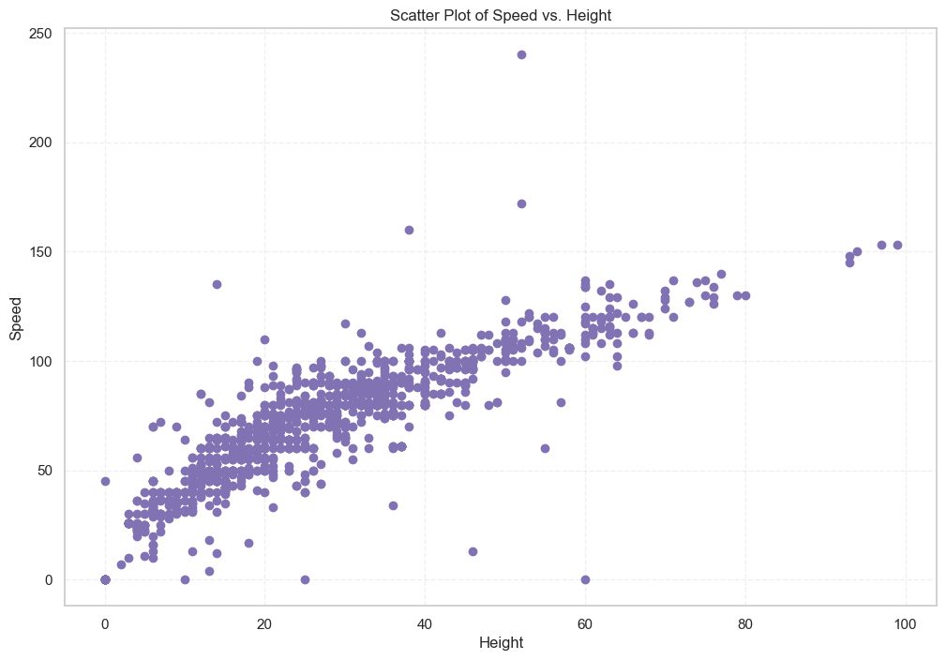

Intrigued by the link between height and speed in coasters, I dug into the data. While there's definitely a connection, with taller coasters generally reaching higher speeds, it's not a perfect recipe for thrills! The top 3 speedsters actually sit near the average height mark, proving there's more to coaster velocity than just skyward ambitions.

### **2.8** **Number of Inversions of Six Flags Great Adventure Roller Coasters**

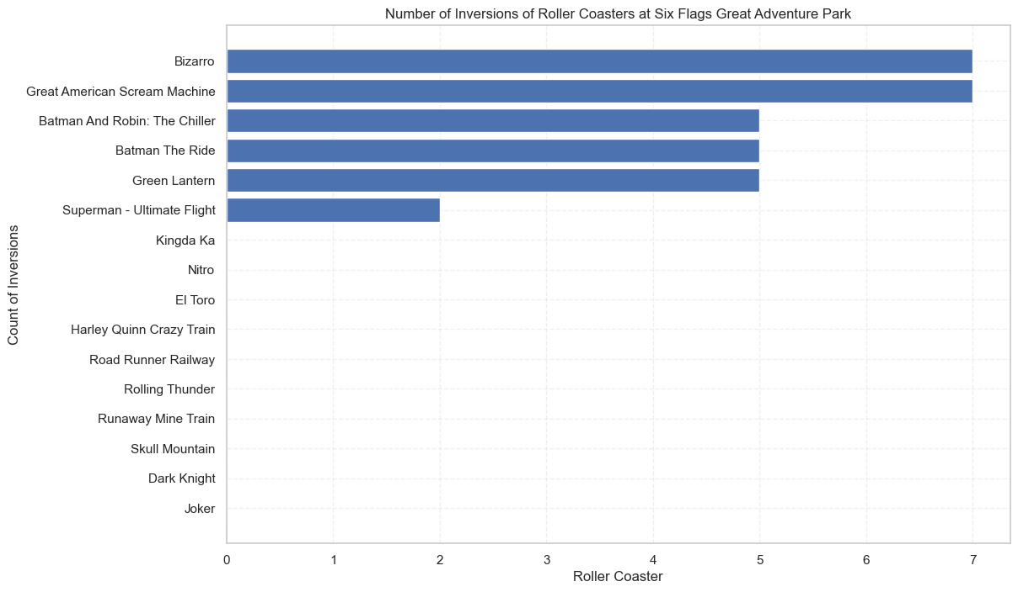

Ever wonder how many upside-down loops and thrilling corkscrews different parks have? With our amazing function, you can easily check any park's inversion count!

Six Flags parks are famous for having the most roller coasters in one place so I used our function to compare inversions of coasters located in these parks.

## **Conclusions**

**Top Thrills:**

* Boulder Dash ruled for years, but El Toro and Phoenix emerged as rising stars, showcasing the dynamic nature of coaster rankings.

**Coaster Heights:**

* Most stand between 5 and 37 meters tall, with only a few daring giants exceeding 50 meters.

**Operational Status:**

* An impressive 77.5% of coasters are ready to rumble, with more on the horizon!

**Park Feature Champions:**

* From Ferrari World's breakneck speeds to Golem Park's marathon tracks, there's a perfect park for every thrill seeker, whether you crave speed, inversions, or epic journeys.

**Seat vs. Feature:**

* While sit-down seats dominate, niche kings reign supreme in specific realms.
* Floorless seats offer the best overall experience, while wing seats conquer speed and height.
* Stand-up, alpine, and wing seats share the title of endurance kings.

**Speed vs. Height:**

* Taller coasters tend to go faster, but it's not a guaranteed equation! Top speed demons hover near the average height, hinting at other factors influencing velocity.

Remember, this is just the beginning of your coaster expedition! Use the provided functions to uncover even more secrets, compare your favorites, and plot your next adrenaline-fueled adventure.